**Creating & Using Views for Student Scores**

**Objective**

Enhance database efficiency and reusability by creating SQL views to manage student scores, pass status, subject performance, and top scorers.

**1. Database Setup & Table Creation**

**1.1 Create students Table**

CREATE TABLE students ( student_id INT PRIMARY KEY, name VARCHAR(100) );

**1.2 Create scores Table**

CREATE TABLE scores ( student_id INT, subject VARCHAR(50), score INT, FOREIGN KEY (student_id) REFERENCES students(student_id) );

**1.3 Sample Data Insertion**

INSERT INTO students VALUES (1, 'Ayesha'), (2, 'Raj'), (3, 'Meena'), (4, 'Arjun');

INSERT INTO scores VALUES (1, 'Math', 85), (1, 'Science', 72), (2, 'Math', 39), (2, 'Science', 51), (3, 'Math', 64), (3, 'Science', 88), (4, 'Math', 40), (4, 'Science', 40);

**Output:**

**Student Table**

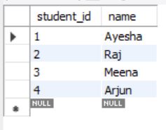

**Scores Table**

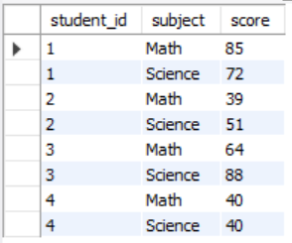

**Output Explanation:**  
Populated database with sample students and their scores across subjects. Ready for view creation and analysis.

**2. SQL Views for Analysis**

**2.1 View: Student Scores**

CREATE VIEW student_scores AS SELECT s.student_id, s.name, sc.subject, sc.score FROM students s JOIN scores sc ON s.student_id = sc.student_id;

SELECT * FROM student_scores;

**Output:**  
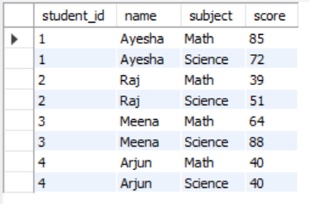

**Output Explanation:**  
 Displays student names with subject-wise scores for streamlined access and reporting.

**2.2 View: Students Who Passed All Subjects**

CREATE VIEW passed_students AS SELECT student_id, name FROM students WHERE student_id NOT IN ( SELECT student_id FROM scores WHERE score < 40 );

SELECT * FROM passed_students;

**Output:**

**  
Output Explanation:**  
 Lists students with all scores ≥ 40, helping identify consistent academic performers.

**2.3 View: Subject-Wise Average Scores**

CREATE VIEW subject_average_scores AS SELECT subject, AVG(score) AS average_score FROM scores GROUP BY subject;

SELECT * FROM subject_average_scores;

**Output:**

**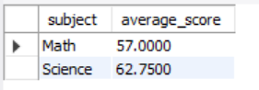  
Output Explanation:**  
 Highlights average scores per subject for curriculum performance insights.

**2.4.View: Top Scorers by Subject**

CREATE VIEW subject_top_scorers AS SELECT sc.student_id, s.name, sc.subject, sc.score FROM scores sc JOIN students s ON sc.student_id = s.student_id WHERE sc.score = ( SELECT MAX(score) FROM scores WHERE subject = sc.subject );

SELECT * FROM subject_top_scorers;

**Output:**

**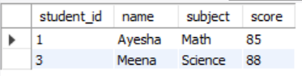  
Output Explanation:**  
 Identifies top-scoring students per subject, useful for academic recognition.

**Summary of Findings (Brief)**

* **student_scores**: Displays all student names, subjects, and their scores.
* **passed_students**: Lists students who scored ≥ 40 in every subject.
* **subject_average_scores**: Reveals average score per subject—Math appears lower than Science.
* **subject_top_scorers**: Identifies highest scoring student(s) per subject, helpful for recognizing excellence.